# Lab 6.4.1: Basic Inter-VLAN Routing

## Topology Diagram

## E3_Lab_6_4_1-graphic

## Addressing Table

|  |  |  |  |  |
| --- | --- | --- | --- | --- |
| **Device**  **(Hostname)** | **Interface** | **IP Address** | **Subnet Mask** | **Default Gateway** |
| **S1** | **VLAN 99** | 172.17.99.11 | 255.255.255.0 | 172.17.99.1 |
| **S2** | **VLAN 99** | 172.17.99.12 | 255.255.255.0 | 172.17.99.1 |
| **S3** | **VLAN 99** | 172.17.99.13 | 255.255.255.0 | 172.17.99.1 |
| **R1** | **Fa 0/0** | 172.17.50.1 | 255.255.255.0 | N/A |
| **R1** | **Fa 0/1** | See Interface Configuration Table | | N/A |
| **PC1** | **NIC** | 172.17.10.21 | 255.255.255.0 | 172.17.10.1 |
| **PC2** | **NIC** | 172.17.20.22 | 255.255.255.0 | 172.17.20.1 |
| **PC3** | **NIC** | 172.17.30.23 | 255.255.255.0 | 172.17.30.1 |
| **Server** | **NIC** | 172.17.50.254 | 255.255.255.0 | 172.17.50.1 |

## Port Assignments – Switch 2

|  |  |  |
| --- | --- | --- |
| **Ports** | **Assignment** | **Network** |
| Fa0/1 – 0/5 | 802.1q Trunks (Native VLAN 99) | 172.17.99.0 /24 |
| Fa0/6 – 0/10 | VLAN 30 – Guest (Default) | 172.17.30.0 /24 |
| Fa0/11 – 0/17 | VLAN 10 – Faculty/Staff | 172.17.10.0 /24 |
| Fa0/18 – 0/24 | VLAN 20 - Students | 172.17.20.0 /24 |

## Interface Configuration Table – Router 1

|  |  |  |
| --- | --- | --- |
| **Interface** | **Assignment** | **IP Address** |
| Fa0/1.1 | VLAN1 | 172.17.1.1 /24 |
| Fa0/1.10 | VLAN 10 | 172.17.10.1 /24 |
| Fa0/1.20 | VLAN 20 | 172.17.20.1 /24 |
| Fa0/1.30 | VLAN 30 | 172.17.30.1 /24 |
| Fa0/1.99 | VLAN 99 | 172.17.99.1 /24 |

## Learning Objectives

Upon completion of this lab, you will be able to:

* Cable a network according to the topology diagram
* Clear configurations and reload a switch and a router to the default state
* Perform basic configuration tasks on a switched LAN and router
* Configure VLANs and VLAN Trunking Protocol (VTP) on all switches
* Demonstrate and explain the impact of Layer 3 boundaries imposed by creating VLANs
* Configure a router to support 802.1q trunking on a Fast Ethernet interface
* Configure a router with subinterfaces corresponding to the configured VLANs
* Demonstrate and explain inter-VLAN routing

Task 1: Prepare the Network

Step 1: Cable a network that is similar to the one in the topology diagram.

The output shown in this lab is based on 2960 switches and an 1841 router. You can use any current switches or routers in your lab as long as they have the required interfaces shown in the topology diagram. Other device types may produce different output. Note that Ethernet (10Mb) LAN interfaces on routers do not support trunking, and Cisco IOS software earlier than version 12.3 may not support trunking on Fast Ethernet router interfaces.

Set up console connections to all three switches and to the router.

Step 2: Clear any existing configurations on the switches.

Clear NVRAM, delete the vlan.dat file, and reload the switches. Refer to lab 2.2.1 if necessary for the procedure. After the reload is complete, use the **show vlan** command to confirm that only default VLANs exist and that all ports are assigned to VLAN 1.

Switch#**show vlan**

VLAN Name Status Ports

---- -------------------------------- --------- -----------------------------

1 default active Fa0/1, Fa0/2, Fa0/3, Fa0/4

Fa0/5, Fa0/6, Fa0/7, Fa0/8

Fa0/9, Fa0/10, Fa0/11, Fa0/12

Fa0/13, Fa0/14, Fa0/15,Fa0/16

Fa0/17, Fa0/18, Fa0/19,Fa0/20

Fa0/21, Fa0/22, Fa0/23,Fa0/24

Gig0/1, Gig0/2

1002 fddi-default active

1003 token-ring-default active

1004 fddinet-default active

1005 trnet-default active

Step 3: Disable all ports using the shutdown command.

Ensure that the initial switch port states are inactive by disabling all ports. Use the **interface range** command to simplify this task. Repeat these commands on each switch in the topology.

Switch(config)#**interface range fa0/1-24**

Switch(config-if-range)#**shutdown**

Switch(config-if-range)#**interface range gi0/1-2**

Switch(config-if-range)#**shutdown**

Task 2: Perform Basic Switch Configurations

Step 1: Configure the S1, S2, and S3 switches.

Use the addressing table and the following guidelines:

* Configure the switch hostname.
* Disable DNS lookup.
* Configure an enable secret password of **class**.
* Configure a password of **cisco** for console connections.
* Configure a password of **cisco** for vty connections.
* Configure the default gateway on each switch

**Output for S1 shown**

Switch>**enable**

Switch#**configure terminal**

Enter configuration commands, one per line. End with CNTL/Z.

Switch(config)#**hostname S1**

S1(config)#**enable secret class**

S1(config)#**no ip domain-lookup**

S1(config)#**ip default-gateway 172.17.99.1**

S1(config)#**line console 0**

S1(config-line)#**password cisco**

S1(config-line)#**login**

S1(config-line)#**line vty 0 15**

S1(config-line)#**password cisco**

S1(config-line)#**login**

S1(config-line)#**end**

%SYS-5-CONFIG\_I: Configured from console by console

S1#**copy running-config startup-config**

Destination filename [startup-config]? [**enter**]

Building configuration...

Step 2: Re-enable the active user ports on S2 in access mode.

S2(config)#**interface fa0/6**

S2(config-if)#**switchport mode access**

S2(config-if)#**no shutdown**

S2(config-if)#**interface fa0/11**

S2(config-if)#**switchport mode access**

S2(config-if)#**no shutdown**

S2(config-if)#**interface fa0/18**

S2(config-if)#**switchport mode access**

S2(config-if)#**no shutdown**

Task 3: Configure the Ethernet Interfaces on the Host PCs

Configure the Ethernet interfaces of PC1, PC2, PC3 and the remote TFTP/Web Server with the IP addresses from the addressing table.

Task 4: Configure VTP on the Switches

Step 1: Configure VTP on the three switches using the following table. Remember that VTP domain names and passwords are case-sensitive.

|  |  |  |  |
| --- | --- | --- | --- |
| **Switch Name** | **VTP Operating Mode** | **VTP Domain** | **VTP Password** |
| **S1** | **Server** | **Lab6** | **cisco** |
| **S2** | **Client** | **Lab6** | **cisco** |
| **S3** | **Client** | **Lab6** | **cisco** |

**S1:**

S1(config)#**vtp mode server**

Device mode already VTP SERVER.

S1(config)#**vtp domain Lab6**

Changing VTP domain name from NULL to Lab6

S1(config)#**vtp password cisco**

Setting device VLAN database password to cisco

S1(config)#end

**S2:**

S2(config)#**vtp mode client**

Setting device to VTP CLIENT mode

S2(config)#**vtp domain Lab6**

Changing VTP domain name from NULL to Lab6

S2(config)#**vtp password cisco**

Setting device VLAN database password to cisco

S2(config)#end

**S3:**

S3(config)#**vtp mode client**

Setting device to VTP CLIENT mode

S3(config)#**vtp domain Lab6**

Changing VTP domain name from NULL to Lab6

S3(config)#**vtp password cisco**

Setting device VLAN database password to cisco

S3(config)#end

Step 2: Configure trunking ports and designate the native VLAN for the trunks.

Configure Fa0/1 through Fa0/5 as trunking ports, and designate VLAN 99 as the native VLAN for these trunks. Use the **interface range** command in global configuration mode to simplify this task.

S1(config)#**interface range fa0/1-5**

S1(config-if-range)#**switchport mode trunk**

S1(config-if-range)#**switchport trunk native vlan 99**

S1(config-if-range)#**no shutdown**

S1(config-if-range)#**end**

S2(config)# **interface range fa0/1-5**

S2(config-if-range)#**switchport mode trunk**

S2(config-if-range)#**switchport trunk native vlan 99**

S2(config-if-range)#**no shutdown**

S2(config-if-range)#**end**

S3(config)# **interface range fa0/1-5**

S3(config-if-range)#**switchport mode trunk**

S3(config-if-range)#**switchport trunk native vlan 99**

S3(config-if-range)#**no shutdown**

S3(config-if-range)#**end**

Step 3: Configure VLANs on the VTP server.

Configure the following VLANS on the VTP server:

|  |  |
| --- | --- |
| **VLAN** | **VLAN Name** |
| **VLAN 99** | **management** |
| **VLAN 10** | **faculty-staff** |
| **VLAN 20** | **students** |
| **VLAN 30** | **guest** |

S1(config)#**vlan 99**

S1(config-vlan)#**name management**

S1(config-vlan)#**exit**

S1(config)#**vlan 10**

S1(config-vlan)#**name faculty-staff**

S1(config-vlan)#**exit**

S1(config)#**vlan 20**

S1(config-vlan)#**name students**

S1(config-vlan)#**exit**

S1(config)#**vlan 30**

S1(config-vlan)#**name guest**

S1(config-vlan)#**end**

Verify that the VLANs have been created on S1 with the **show vlan brief** command.

Step 4: Verify that the VLANs created on S1 have been distributed to S2 and S3.

Use the **show vlan brief** command on S2 and S3 to verify that the four VLANs have been distributed to the client switches.

S2#**show vlan brief**VLAN Name Status Ports

---- -------------------------------- --------- -----------------------------

1 default active Fa0/1, Fa0/2, Fa0/4, Fa0/5

Fa0/6, Fa0/7, Fa0/8, Fa0/9

Fa0/10, Fa0/11, Fa0/12,Fa0/13

Fa0/14, Fa0/15, Fa0/16,Fa0/17

Fa0/18, Fa0/19, Fa0/20,Fa0/21

Fa0/22, Fa0/23, Fa0/24, Gi0/1

Gi0/2

10 faculty-staff active

20 students active

30 guest active

99 management active

Step 5: Configure the management interface address on all three switches.

S1(config)#**interface vlan 99**

S1(config-if)#**ip address 172.17.99.11 255.255.255.0**

S1(config-if)#**no shutdown**

S1(config-if)#**end**

S2(config)#**interface vlan 99**

S2(config-if)#**ip address 172.17.99.12 255.255.255.0**

S2(config-if)#**no shutdown**

S2(config-if)#**end**

S3(config)#**interface vlan 99**

S3(config-if)#**ip address 172.17.99.13 255.255.255.0**

S3(config-if)#**no shutdown**

S3(config-if)#**end**

Verify that the switches are correctly configured by pinging between them. From S1, ping the management interface on S2 and S3. From S2, ping the management interface on S3.

Were the pings successful? Yes

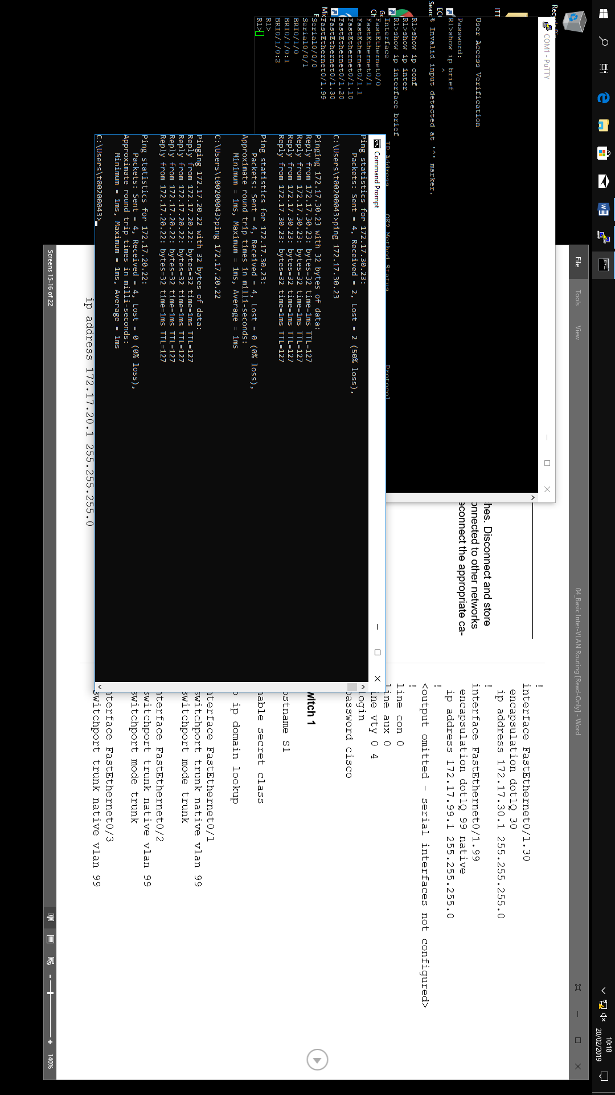If not, troubleshoot the switch configurations and try again.

Step 6: Assign switch ports to VLANs on S2.

Refer to the port assignments table at the beginning of the lab to assign ports to VLANs on S2.

S2(config)#**interface range fa0/6-10**

S2(config-if-range)#**switchport access vlan 30**

S2(config-if-range)#**interface range fa0/11-17**

S2(config-if-range)#**switchport access vlan 10**

S2(config-if-range)#**interface range fa0/18-24**

S2(config-if-range)#**switchport access vlan 20**

S2(config-if-range)#**end**

S2#**copy running-config startup-config**

Destination filename [startup-config]? [**enter**]

Building configuration...

[OK]

Step 7: Check connectivity between VLANs.

Open command windows on the three hosts connected to S2. Ping from PC1 (172.17.10.21) to PC2 (172.17.20.22). Ping from PC2 to PC3 (172.17.30.23).

Are the pings successful? No

If not, why do these pings fail? PC’s which share a switch cannot ping each other.

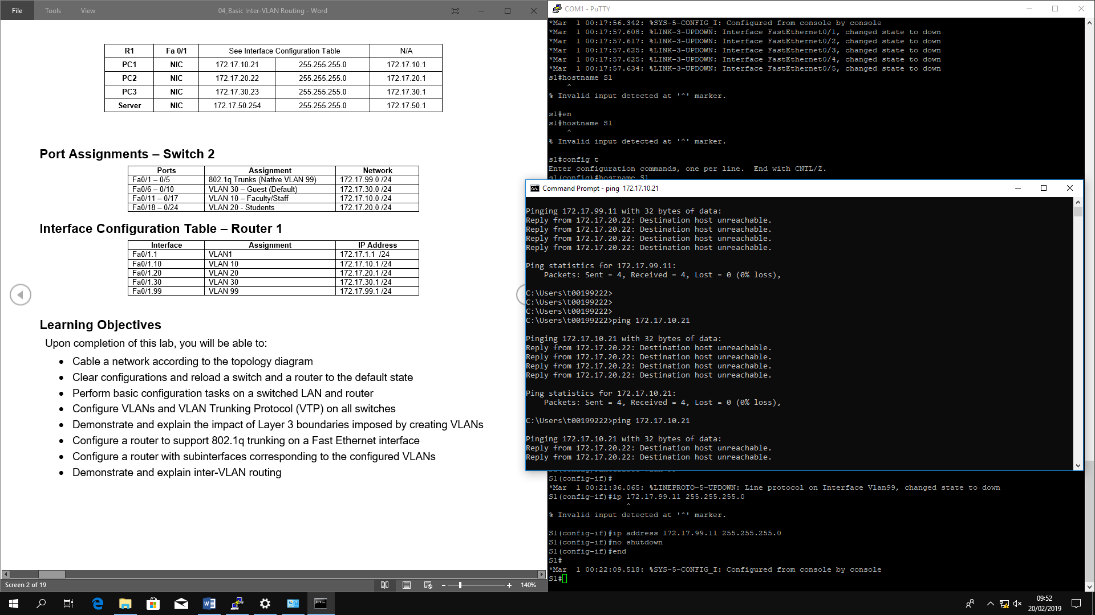

Task 5: Configure the Router and the Remote Server LAN

Step 1: Clear the configuration on the router and reload.

Router#**erase nvram:**

Erasing the nvram filesystem will remove all configuration files! Continue? [confirm]

Erase of nvram: complete

Router#**reload**

System configuration has been modified. Save? [yes/no]: **no**

Step 2: Create a basic configuration on the router.

* Configure the router with hostname R1.
* Disable DNS lookup.
* Configure an EXEC mode password of **cisco**.
* Configure a password of **cisco** for console connections.
* Configure a password of **cisco** for vty connections.

Step 3: Configure the trunking interface on R1.

You have demonstrated that connectivity between VLANs requires routing at the network layer, exactly like connectivity between any two remote networks. There are a couple of options for configuring routing between VLANs.

The first is something of a brute force approach. An L3 device, either a router or a Layer 3 capable switch, is connected to a LAN switch with multiple connections—a separate connection for each VLAN that requires inter-VLAN connectivity. Each of the switch ports used by the L3 device is configured in a different VLAN on the switch. After IP addresses are assigned to the interfaces on the L3 device, the routing table has directly connected routes for all VLANS, and inter-VLAN routing is enabled. The limitations to this approach are the lack of sufficient Fast Ethernet ports on routers, under-utilization of ports on L3 switches and routers, and excessive wiring and manual configuration. The topology used in this lab does not use this approach.

An alternative approach is to create one or more Fast Ethernet connections between the L3 device (the router) and the distribution layer switch, and to configure these connections as dot1q trunks. This allows all inter-VLAN traffic to be carried to and from the routing device on a single trunk. However, it requires that the L3 interface be configured with multiple IP addresses. This can be done by creating “virtual” interfaces, called subinterfaces, on one of the router Fast Ethernet ports and configuring them to dot1q aware.

Using the subinterface configuration approach requires these steps:

* Enter subinterface configuration mode
* Establish trunking encapsulation
* Associate a VLAN with the subinterface
* Assign an IP address from the VLAN to the subinterface

The commands are as follows:

R1(config)#interface fastethernet 0/1   
R1(config-if)#no shutdown

R1(config-if)#interface fastethernet 0/1.1   
R1(config-subif)#encapsulation dot1q 1   
R1(config-subif)#ip address 172.17.1.1 255.255.255.0

R1(config-if)#interface fastethernet 0/1.10  
R1(config-subif)#encapsulation dot1q 10   
R1(config-subif)#ip address 172.17.10.1 255.255.255.0

R1(config-if)#interface fastethernet 0/1.20  
R1(config-subif)#encapsulation dot1q 20   
R1(config-subif)#ip address 172.17.20.1 255.255.255.0

R1(config-if)#interface fastethernet 0/1.30  
R1(config-subif)#encapsulation dot1q 30   
R1(config-subif)#ip address 172.17.30.1 255.255.255.0

R1(config-if)#interface fastethernet 0/1.99  
R1(config-subif)#encapsulation dot1q 99 native  
R1(config-subif)#ip address 172.17.99.1 255.255.255.0

Note the following points in this configuration:

* The physical interface is enabled using the **no shutdown** command, because router interfaces are down by default. The virtual interfaces are up by default.
* The subinterface can use any number that can be described with 32 bits, but it is good practice to assign the number of the VLAN as the interface number, as has been done here.
* The native VLAN is specified on the L3 device so that it is consistent with the switches. Otherwise, VLAN 1 would be the native VLAN by default, and there would be no communication between the router and the management VLAN on the switches.

Confirm creation and status of the subinterfaces with the **show ip interface brief** command:

R1#**show ip interface brief**

Interface IP-Address OK? Method Status Protocol

FastEthernet0/0 unassigned YES unset administratively down down

FastEthernet0/1 unassigned YES unset up up

FastEthernet0/1.1 172.17.1.1 YES manual up up

FastEthernet0/1.10 172.17.10.1 YES manual up up

FastEthernet0/1.20 172.17.20.1 YES manual up up

FastEthernet0/1.30 172.17.30.1 YES manual up up

FastEthernet0/1.99 172.17.99.1 YES manual up up

Step 4: Configure the server LAN interface on R1.

R1(config)# **interface FastEthernet0/0**

R1(config-if)#**ip address 172.17.50.1 255.255.255.0**

R1(config-if)#**description server interface**

R1(config-if)#**no shutdown**

R1(config-if)#**end**

There are now six networks configured. Verify that you can route packets to all six by checking the routing table on R1.

R1#**show ip route**

<output omitted>

Gateway of last resort is not set

172.17.0.0/24 is subnetted, 6 subnets

C 172.17.50.0 is directly connected, FastEthernet0/0

C 172.17.30.0 is directly connected, FastEthernet0/1.30

C 172.17.20.0 is directly connected, FastEthernet0/1.20

C 172.17.10.0 is directly connected, FastEthernet0/1.10

C 172.17.1.0 is directly connected, FastEthernet0/1.1

C 172.17.99.0 is directly connected, FastEthernet0/1.99

If your routing table does not show all six networks, troubleshoot your configuration and resolve the problem before proceeding.

Step 5: Verify Inter-VLAN routing.

From PC1, verify that you can ping the remote server (172.17.50.254) and the other two hosts (172.17.20.22 and 172.17.30.23). It may take a couple of pings before the end-to-end path is established.

Are the pings successful? Yes

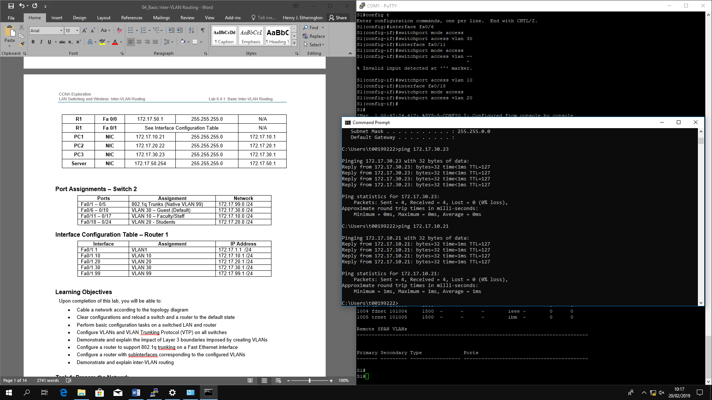

If not, troubleshoot your configuration. Check to make sure that the default gateways have been set on all PCs and all switches. If any of the hosts have gone into hibernation, the connected interface may go down.

Task 6: Reflection

In Task 5, it was recommended that you configure VLAN 99 as the native VLAN in the router Fa0/0.99 interface configuration. Why would packets from the router or hosts fail when trying to reach the switch management interfaces if the native VLAN were left in default?

The vlan for fa0/6, fa0/11 and fa0/18(vlans 30, 10 and 20 respectively) would be located on the same vlan (vlan 99) as the switches which is on the default for all trunk ports. They must be of type access mode to function.

Task 7: Clean Up

Erase the configurations and reload the switches. Disconnect and store the cabling. For PC hosts that are normally connected to other networks (such as the school LAN or to the Internet), reconnect the appropriate cabling and restore the TCP/IP settings.

**Final Configurations**

**Router 1**

hostname R1

!

enable secret class

!

no ip domain lookup

!

interface FastEthernet0/0

ip address 172.17.50.1 255.255.255.0

no shutdown

!

interface FastEthernet0/1

no shutdown

!

interface FastEthernet0/1.1

encapsulation dot1Q 1

ip address 172.17.1.1 255.255.255.0

!

interface FastEthernet0/1.10

encapsulation dot1Q 10

ip address 172.17.10.1 255.255.255.0

!

interface FastEthernet0/1.20

encapsulation dot1Q 20

ip address 172.17.20.1 255.255.255.0

!

interface FastEthernet0/1.30

encapsulation dot1Q 30

ip address 172.17.30.1 255.255.255.0

!

interface FastEthernet0/1.99

encapsulation dot1Q 99 native

ip address 172.17.99.1 255.255.255.0

!

<output omitted - serial interfaces not configured>

!

line con 0

line aux 0

line vty 0 4

login

password cisco

!

**Switch 1**

!

hostname S1

!

enable secret class

!

no ip domain lookup

!

interface FastEthernet0/1

switchport trunk native vlan 99

switchport mode trunk

!

interface FastEthernet0/2

switchport trunk native vlan 99

switchport mode trunk

!

interface FastEthernet0/3

switchport trunk native vlan 99

switchport mode trunk

!

interface FastEthernet0/4

switchport trunk native vlan 99

switchport mode trunk

!

interface FastEthernet0/5

switchport trunk native vlan 99

switchport mode trunk

!

<output omitted - all remaining ports in shutdown>

!

interface Vlan1

no ip address

no ip route-cache

!

interface Vlan99

ip address 172.17.99.11 255.255.255.0

no shutdown

!

ip default-gateway 172.17.99.1

ip http server

!

line con 0

logging synchronous

line vty 0 4

login

password cisco

line vty 5 15

login

password cisco

**Switch 2**

!

hostname S2

!

enable secret class

!

no ip domain lookup

!

interface FastEthernet0/1

switchport trunk native vlan 99

switchport mode trunk

!

interface FastEthernet0/2

switchport trunk native vlan 99

switchport mode trunk

!

interface FastEthernet0/3

switchport trunk native vlan 99

switchport mode trunk

!

interface FastEthernet0/4

switchport trunk native vlan 99

switchport mode trunk

!

interface FastEthernet0/5

switchport trunk native vlan 99

switchport mode trunk

!

interface FastEthernet0/6

switchport access vlan 30

switchport mode access

!

interface FastEthernet0/7

switchport access vlan 30

!

interface FastEthernet0/8

switchport access vlan 30

!

interface FastEthernet0/9

switchport access vlan 30

!

interface FastEthernet0/10

switchport access vlan 30

!

interface FastEthernet0/11

switchport access vlan 10

switchport mode access

!

interface FastEthernet0/12

switchport access vlan 10

!

interface FastEthernet0/13

switchport access vlan 10

!

interface FastEthernet0/14

switchport access vlan 10

!

interface FastEthernet0/15

switchport access vlan 10

!

interface FastEthernet0/16

switchport access vlan 10

!

interface FastEthernet0/17

switchport access vlan 10

!

interface FastEthernet0/18

switchport access vlan 20

!

interface FastEthernet0/19

switchport access vlan 20

!

interface FastEthernet0/20

switchport access vlan 20

!

interface FastEthernet0/21

switchport access vlan 20

!

interface FastEthernet0/22

switchport access vlan 20

!

interface FastEthernet0/23

switchport access vlan 20

!

interface FastEthernet0/24

switchport access vlan 20

!

interface Vlan1

no ip address

no ip route-cache

!

interface Vlan99

ip address 172.17.99.12 255.255.255.0

no shutdown

!

ip default-gateway 172.17.99.1

ip http server

!

line con 0

password cisco

logging synchronous

login

line vty 0 4

password cisco

login

line vty 5 15

password cisco

login

!

end

**Switch 3**

!

hostname S3

!

enable secret class

!

no ip domain lookup

!

interface FastEthernet0/1

switchport trunk native vlan 99

switchport mode trunk

!

interface FastEthernet0/2

switchport trunk native vlan 99

switchport mode trunk

!

interface FastEthernet0/3

switchport trunk native vlan 99

switchport mode trunk

!

interface FastEthernet0/4

switchport trunk native vlan 99

switchport mode trunk

!

interface FastEthernet0/5

switchport trunk native vlan 99

switchport mode trunk

!

<output omitted - all remaining ports in shutdown>

!

interface Vlan99

ip address 172.17.99.13 255.255.255.0

no shutdown

!

ip default-gateway 172.17.99.1

ip http server

!

control-plane

!

line con 0

password cisco

login

line vty 0 4

password cisco

login

line vty 5 15

password cisco

login

!

end